ỦY BAN NHÂN DÂN TP.HCM CỘNG HÒA XÃ HỘI CHỦ NGHĨA VIỆT NAM
TRƯỜNG CAO ĐẲNG LÝ TỰ TRỌNG TPHCM Độc lập – Tự do – Hạnh phúc
********** ******

PHIẾU TRẢ LỜI TRẮC NGHIỆM

Tên: ____________________________________ Đề thi số: 01
Lớp: ___________ Ngày thi: _____________

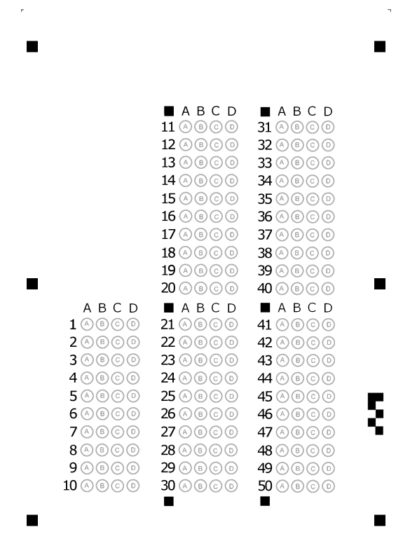

ỦY BAN NHÂN DÂN TP.HCM CỘNG HÒA XÃ HỘI CHỦ NGHĨA VIỆT NAM
TRƯỜNG CAO ĐẲNG LÝ TỰ TRỌNG TPHCM Độc lập – Tự do – Hạnh phúc
********** ******
ĐỀ 1
ĐỀ THI GIỮA HỌC PHẦN LÝ THUYẾT
BẬC ĐÀO TẠO : CAO ĐẲNG
HỌC PHẦN : ANH VĂN
HỌC KỲ : I NĂM HỌC: 2017 - 2018
Lớp: 17C1-KML1, CNO8 Ngày thi: 21 + 23/ 11 / 2017
Thời gian thi : 60 phút
(Sinh viên không được sử dụng tài liệu trong khi làm bài. Sinh viên trả lời vào PHIẾU TRẢ LỜI TRẮC NGHIỆM)
(Đề thi gồm 50 câu. Mỗi câu trả lời đúng được 0.2 điểm)
------------------------------------------------
A. LISTENING
Part I: Listen to the conversations. Choose the names.
1. A. Damien B. David C. Dakid D. Damin
2. A. Jackson B. John C. Johnson D. Jelson
3. A. Rob B. Bob C. Tob D. Cob
4. A. Michelle B. Mary C. Mario D. Marcia
5. A. Smith B. Smid C. Smit D. Schmidt
B. READING
Part II: Incomplete Sentences: Choose the word or phrase that best complete the sentence.
6. They found the money ________ I dropped.
A. who B. whom C. whose D. that
7. The police arrested the man ________ I saw steal a handbag.
A. who B. which C. whose D. that
8. She wrote to her friend ________ lives in Vietnam.
A. whom B. which C. where D. who
9. His friend ________ is a lawyer lives in Scotland.
A. whose B. whom C. who D. which
10. We called the secretary ________ I went to school with.
A. who B. whose C. whom D. which
11. The bag ________ I bought yesterday was stolen.
A. who B. whose C. whom D. which
12. He told me the places and people ________ he had seen in London.
A. which B. who C. whom D. that
13. The TV programme ________ Lucy recommended was very funny.
A. which B. where C. whom D. who
14. That’s the building ________ I work.
A. who B. which C. whom D. where
15. That’s the dog ________ owner is French.
A. which B. whose C. whom D. where

16. Stop worrying ______ your exam – everything will be fine.
A. about B. in C. on D. at
17. I’ve waited ______ Judy for 30 minutes. I’m going home.
A. at B. in C. of D. for
18. I don’t know what we’ll do at the weekend. It depends ______ the weather.
A. in B. on C. for D. about
19. She will arrive ______ Beijing at 3p.m.
A. for B. about C. in D. at
20. You're always asking me ______ some change. Can't you ask someone else this time?
A. for B. to C. on D. about
21. The weather was awful, _____ we didn’t go out.
A. so B. because C. although D. but
22. I didn’t give him my phone number _____ I didn’t want him to call me.
A. although B. but C. so D. because
23. She didn’t like the song _____ it was by one of her favourite bands.
A. but B. so C. although D. then
24. It was her birthday, _____ I invited her to dinner.
A. because B. so C. but D. when
25. He’s an intelligent student, _____ he’s very lazy.
A. but B. although C. after that D. then
26. It never snows here _____ Christmas.
A. in B. on C. at D. for
27. The country looks beautiful _____ spring.
A. in B. on C. with D. about
28. He always comes _____ bus.
A. in B. on C. with D. about
29. I don't like getting up _____ the morning.
A. with B. from C. in D. to
30. I have breakfast _____ 7:30 every morning.
A. about B. in C. on D. at
31. John _______ tennis once or twice a week.
A. is playing usually B. is usually playing C. usually plays D. plays usually
32. What time _______ to work this morning?
A. did you get B. are you getting C. have you got D. do you get
33. He’s worked for this company ______many years.
A. since B. in C. for D. at
34. The earth _______ on the sun for its heat and light
A. is depended B. depends C. is depending D.has depended
35. Don’t bother me while I _____.
A. am working B. was working C. will work D.will completed
36. Everyday, my sister _____ the floor.
A. usually clean B. cleans usually C. usually cleaned D.usually cleans
37. I usually ____ to school by bus.
A. went B. am going C. go D. have gone
38. Water ____ at 100 degrees Celsius.
A. boils B. boiled C. is boiling D. will boil
39. ____ she ____ in Hue at the moment?
A. Does/live B. Is/living C. Did/live D. Was/living
40. Don’t make noise, children! Parents ____.
A. sleep B. are sleeping C. were sleeping D. slept
41. Peter ____ a novel at the moment.
A. reads B. is reading C. is reads D. was reading
42. I have been waiting for you _____
A. since early morning B. since 9 a.m C. for two hours D. all are correct
43. Look! The bus _____.
A. left B. has left C. is leaving D. leaves
44. Tom _______ his hand when he was cooking dinner.
A. burnt B. was burning C. has burnt D. had burnt
45. When I was a child, I _______ the violin.
A. was playing B. am playing C. played D. play
46. When I _______ him, the man was running away.
A. see B. was seeing C. saw D. had seen
47. Jane and I _______ school in 1987.
A. finish B. have finished C. finishes D. finished
48. What ____ he ____ at 4pm last Sunday?
A. did/do B. was/do C. had/done D. was/doing
49. At 5 o’clock yesterday evening, I _____ my clothes.
A. am ironing B. have ironed C. ironed D. was ironing
50. I saw Jack yesterday morning while I ________ home from work.
A. walked C. am walking
B. was walking D. had been walking
The End of the Test
Trưởng khoa Giáo viên soạn đề

Trần Kim Thu Liễu Đinh Trần Phương Thảo

